**Question 2: Process**

*What does the script do?*

My first objective would be to understand the purpose of the script. I would begin by opening the Python script in Visual Studio Code, or another IDE that has helpful tools for understanding the structure of your script. I would run the script, and take a few notes on what the script does. I would also try to reverse engineer the script, and think through the possible ways it was written, or how I might have approached writing the script.

*How did the author/s approach the script?*

Then, I would want to understand the author’s approach to accomplishing the script’s purpose. If the code is hosted on a version control platform like GitHub, I would look at the commit messages to better understand the author’s process. I would then look at the 36 libraries to make sure I was familiar with all of them. If I didn’t recognize a library, I’d spend 5 to 10 minutes looking over the documentation to gain a basic understanding of its functionality. Next, I would check for global variables at the top of the script. If there are any, I’d take a few minutes to understand what they are, and why they were coded as global variables rather than as local variables.

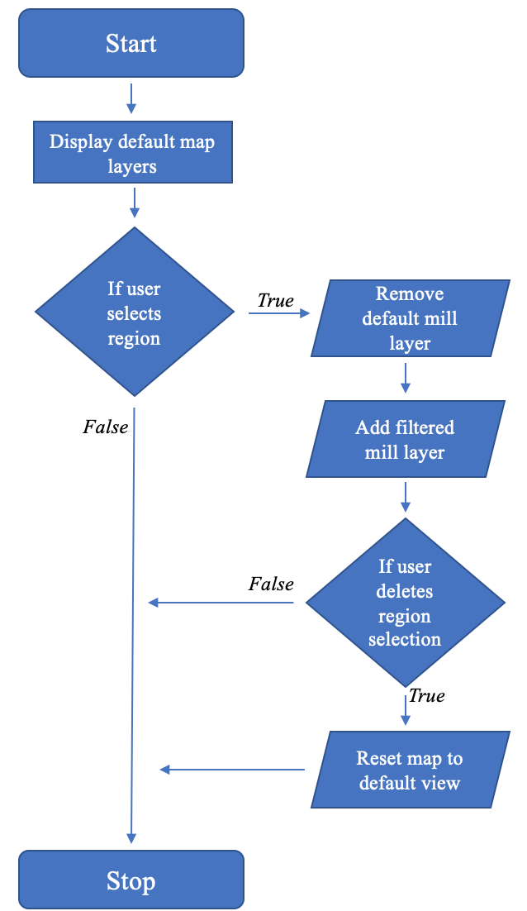

*How does the code work?*

My final step would be to understand the logic of the script, and how each chunk of code works. If the code is organized in functions, I would create an outline of the functions. Then, using the function outline and the main function, I would create a tree diagram or flow chart*. Finally, I would run the code with breakpoints to understand what each chunk of code does.

*I’ve included an example flow chart to the right. This flow chart corresponds to a script that manages the removal and addition of layers to a Leaflet map instance, based on the user’s selections. This particular map shows palm oil mills, and allows users to filter the mills by region.

Sources:

<https://problemsolvingwithpython.com/08-If-Else-Try-Except/08.06-Flowcharts/>

<https://www.programiz.com/article/flowchart-programming>